1.Configure VPC peering in cross regions
Vpc peering: communication between different vpc’s in same region and in different region and different accounts

Cross-Region VPC Peering Configuration in AWS
Cross-region VPC peering allows two VPCs in different AWS regions to communicate privately using private IP addresses.
Example:
- VPC A → us-east-1
- VPC B → us-west-2

Architecture Example
Resource | Region | CIDR
VPC-A | us-east-1 | 10.0.0.0/16
VPC-B | us-west-2 | 192.168.0.0/16

Prerequisites
- Two VPCs in different AWS regions
- CIDR blocks must NOT overlap
- Internet Gateway not required for peering traffic
- Route tables and security groups must allow traffic

Step 1: Create VPCs
Create two VPCs in different regions.

VPC A
- Region: us-east-1
- CIDR: 10.0.0.0/16

VPC B
- Region: us-west-2
- CIDR: 192.168.0.0/16

Step 2: Create Cross-Region Peering Connection

Using AWS Console

From Region us-east-1
- Open VPC Dashboard
- Go to Peering Connections
- Click Create Peering Connection
Provide:
Field | Value
Name | cross-region-peer
Requester VPC | VPC-A
Region | us-west-2
Accepter VPC | VPC-B
Click Create Peering Connection

Step 3: Accept Peering Request
- Switch to region us-west-2
- Open VPC → Peering Connections
- Select pending request
- Click Actions → Accept Request
Status becomes:
Active

Step 4: Update Route Tables

Route Table of VPC-A
Add route:
Destination | Target
192.168.0.0/16 | pcx-xxxxxxxx

Route Table of VPC-B
Add route:
Destination | Target
10.0.0.0/16 | pcx-xxxxxxxx

Step 5: Update Security Groups
Allow inbound traffic from peer VPC CIDR.
Example:

Security Group in VPC-A
Type | Protocol | Port | Source
SSH | TCP | 22 | 192.168.0.0/16

Security Group in VPC-B
Type | Protocol | Port | Source
SSH | TCP | 22 | 10.0.0.0/16

Step 6: Test Connectivity
Launch EC2 instances in both VPCs.
Example:
Instance | Private IP
EC2-A | 10.0.1.10
EC2-B | 192.168.1.10
From EC2-A:
ping 192.168.1.10
Or SSH:
ssh ec2-user@192.168.1.10

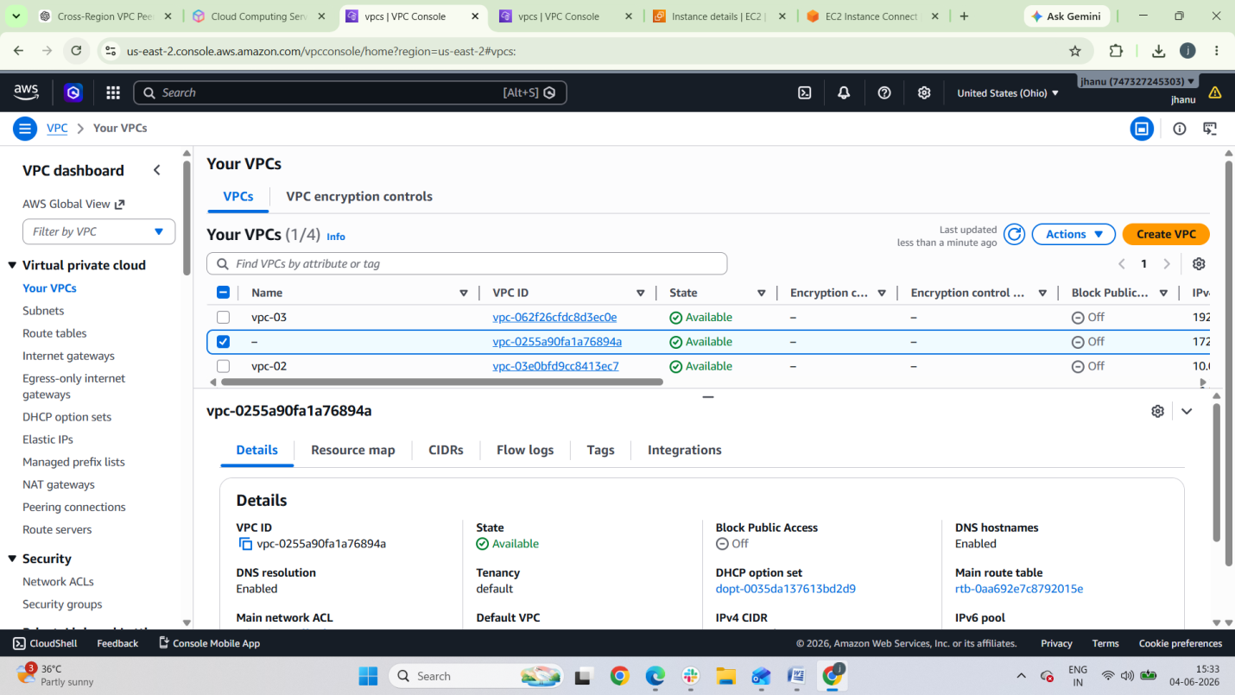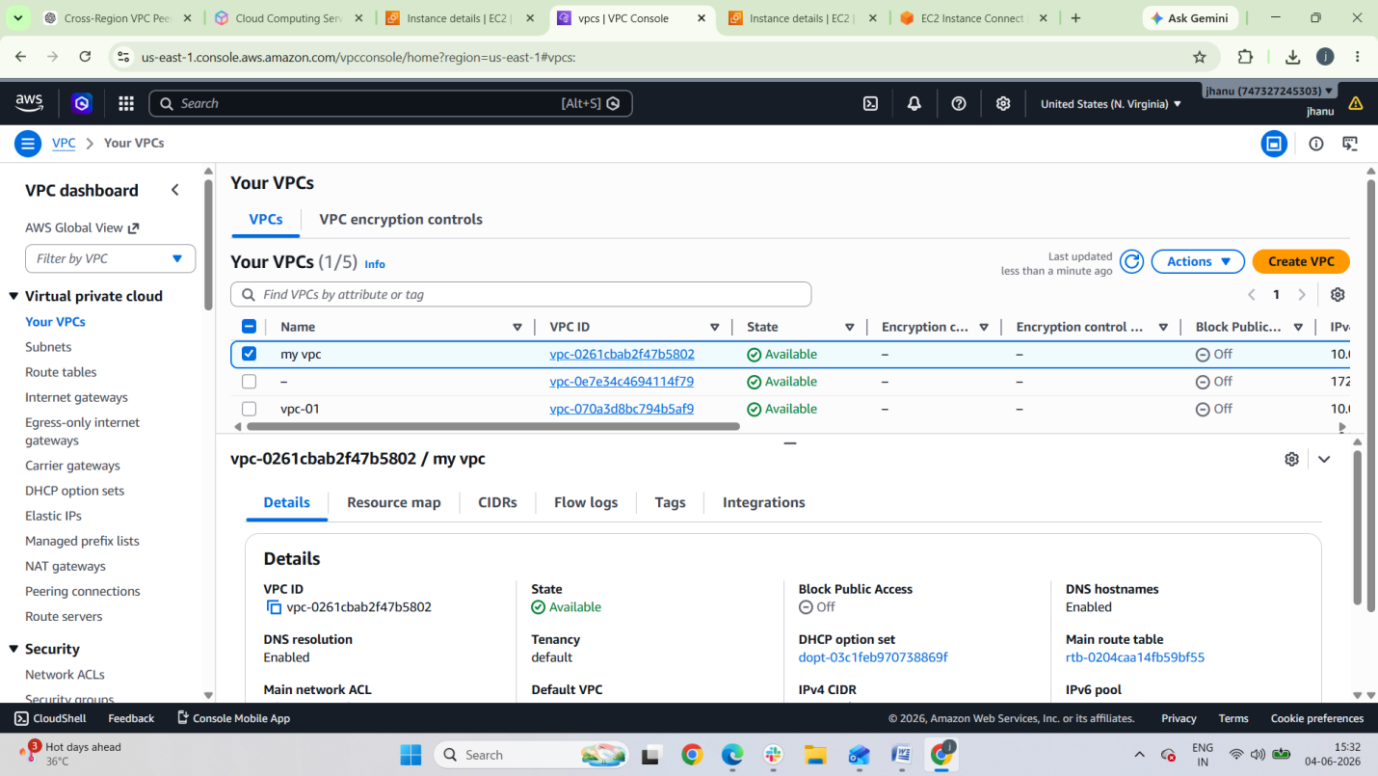

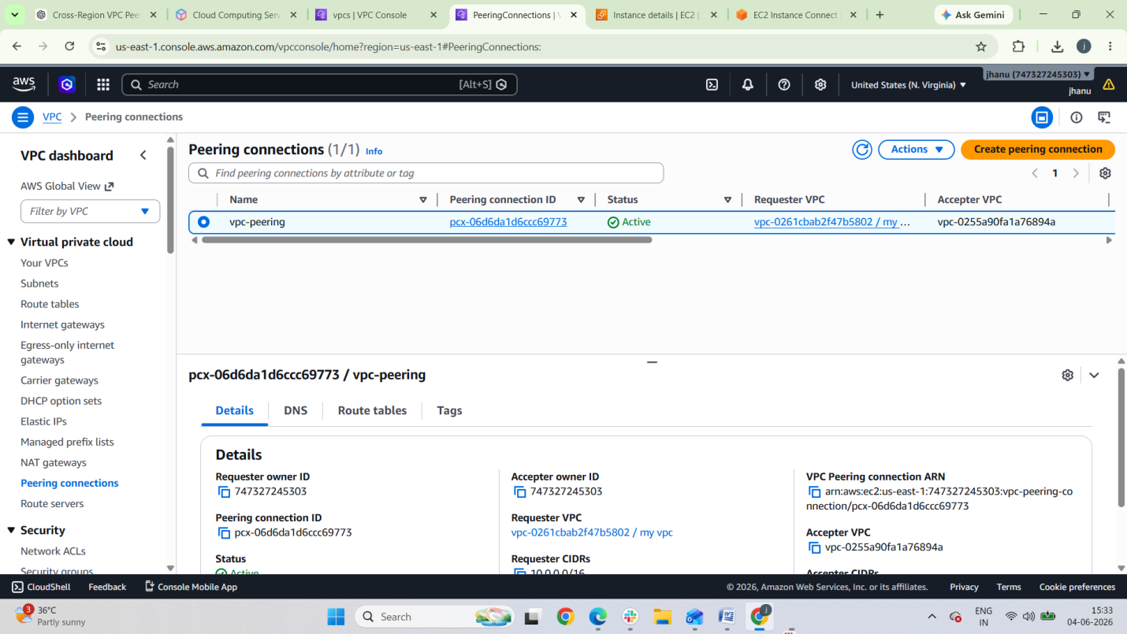

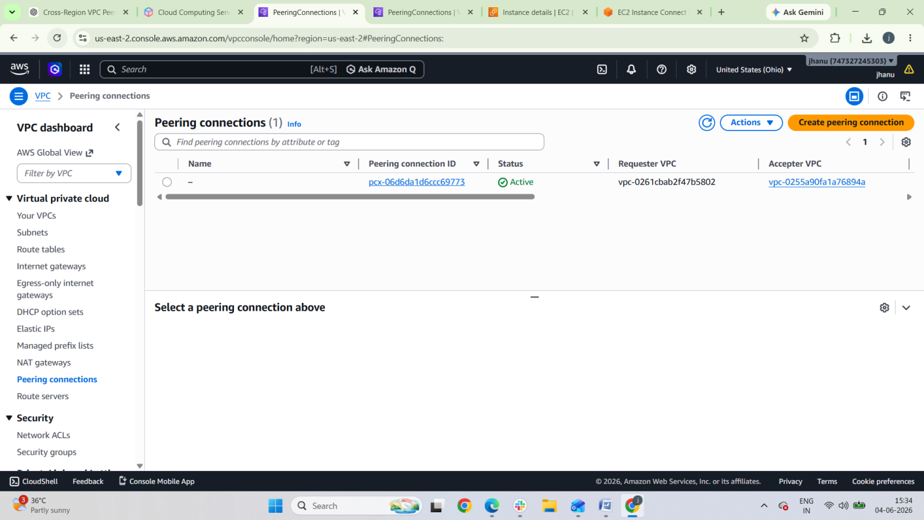

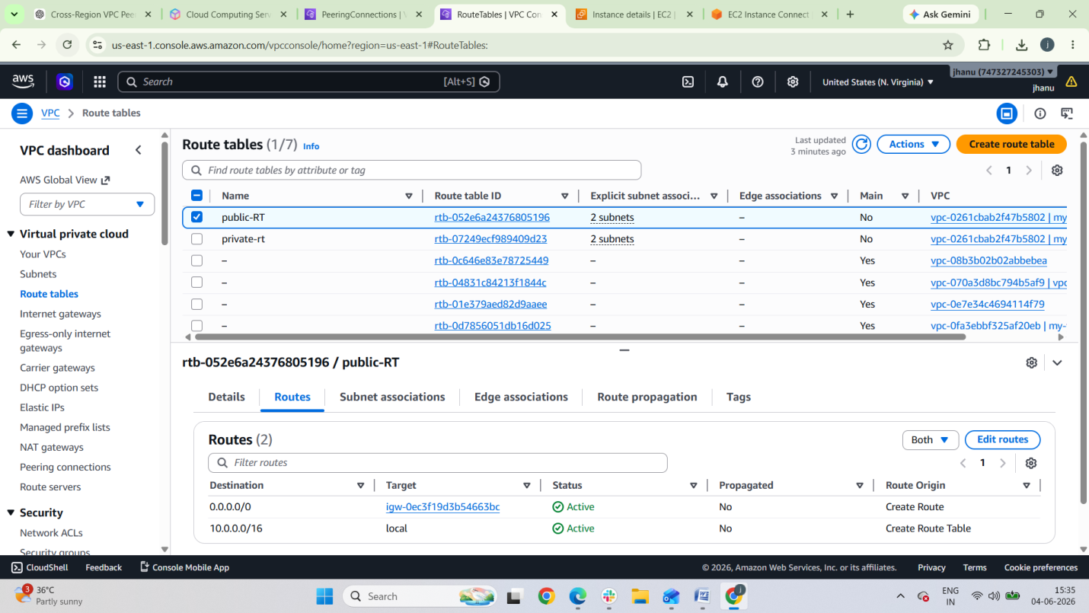

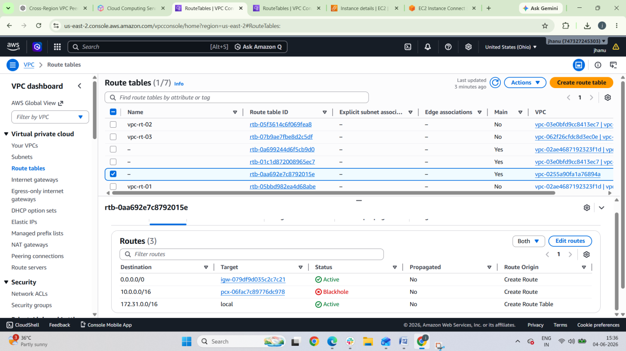
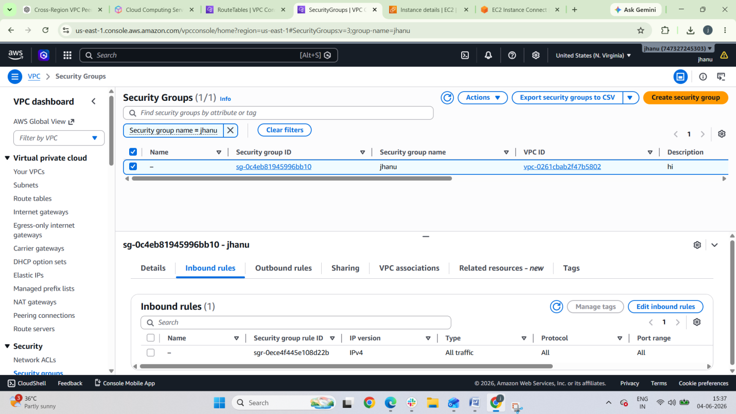

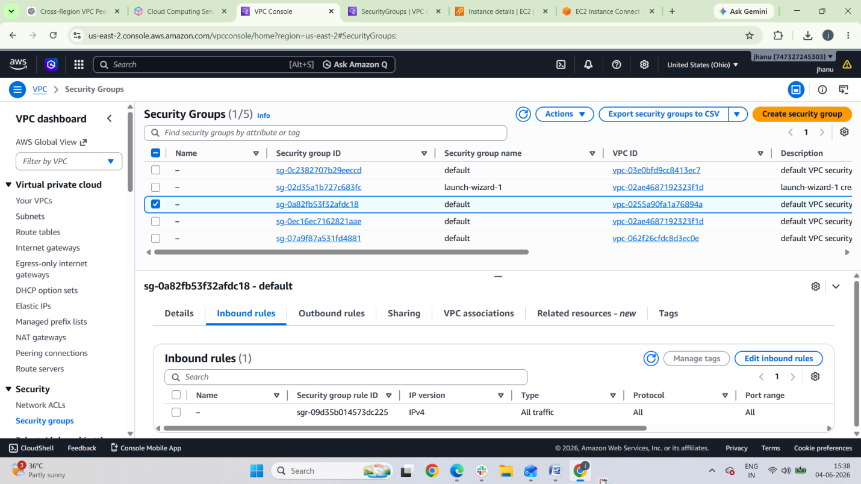

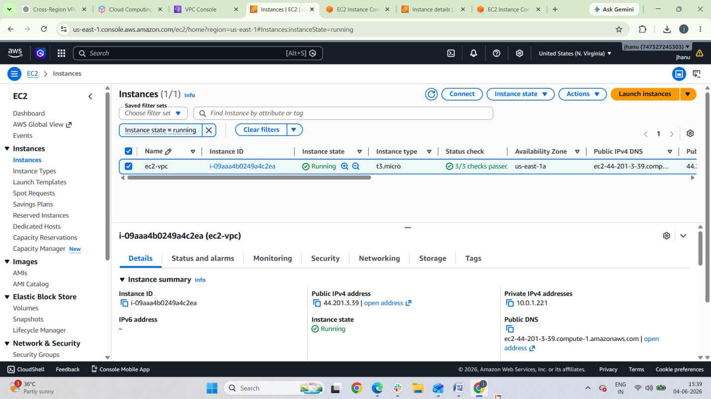
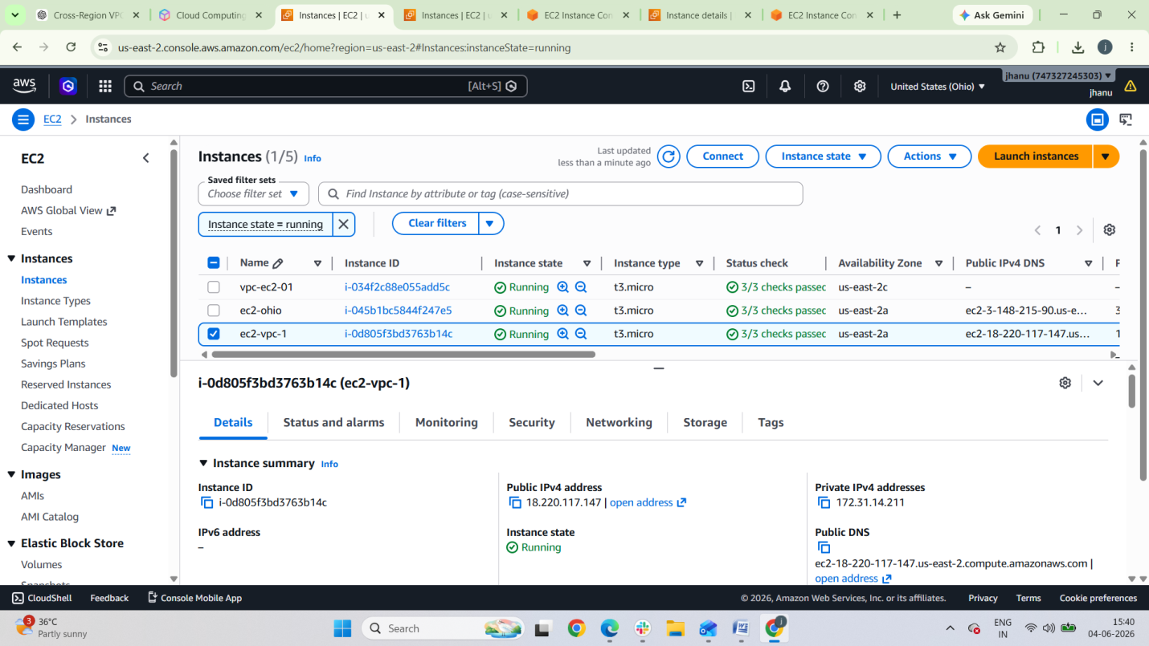

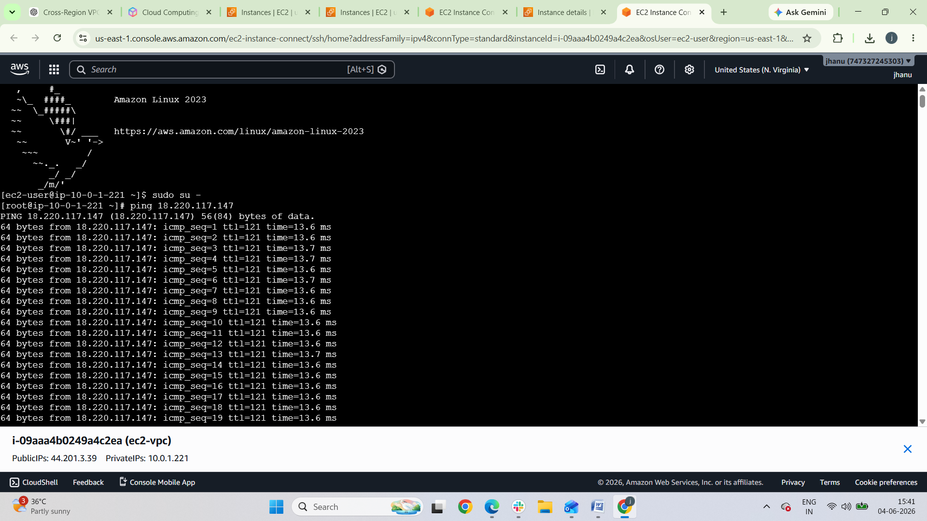

2. Deploy static website in S3.

Deploy Static Website in Amazon S3
Amazon S3 can host static websites like:
- HTML websites
- Portfolio sites
- Landing pages
- React/Angular build files

Architecture
User Browser
│
▼
S3 Bucket (Static Website Hosting)
│
▼
HTML / CSS / JS Files

Step 1: Create an S3 Bucket
- Open AWS Console
- Go to Amazon S3 Console
- Click Create bucket
Example:
Bucket Name: my-static-website-demo
Region: ap-south-1

Step 2: Disable Block Public Access
During bucket creation:
Uncheck:
Block all public access
Acknowledge the warning.
This is required for public website hosting.

Step 3: Upload Website Files
Upload:
- index.html
- style.css
- images
- JS files
Example structure:
index.html
style.css
images/

Step 4: Enable Static Website Hosting
- Open bucket
- Go to Properties
- Scroll to Static website hosting
- Click Edit
- Enable:
Enable
- Hosting type:
Host a static website
- Index document:
index.html
- Error document:
error.html
Save changes.

Step 5: Add Bucket Policy
Go to:
- Permissions
- Bucket Policy
Add:
{
"Version": "2012-10-17",
"Statement": [
{
"Sid": "PublicReadGetObject",
"Effect": "Allow",
"Principal": "*",
"Action": "s3:GetObject",
"Resource": "arn:aws:s3:::my-static-website-demo/*"
}
]
}
Replace:
my-static-website-demo
with your bucket name.

Step 6: Access Website URL
Go to:
- Bucket → Properties
- Static website hosting
You will see endpoint like:
http://my-static-website-demo.s3-website-ap-south-1.amazonaws.com
Open it in browser.

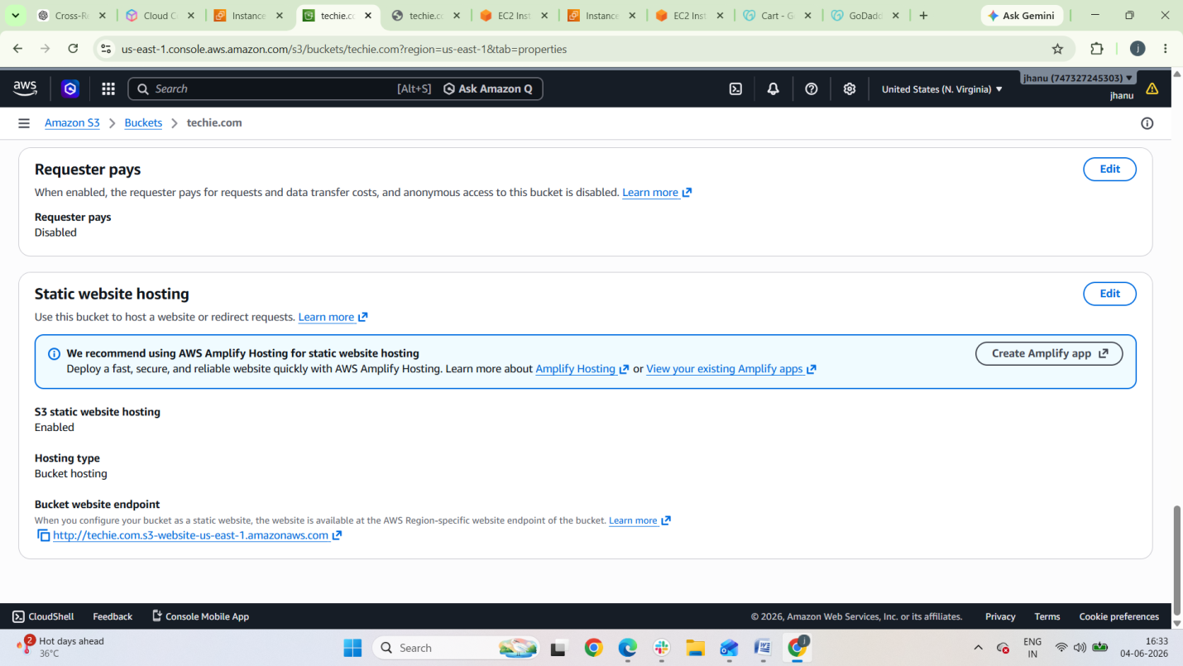

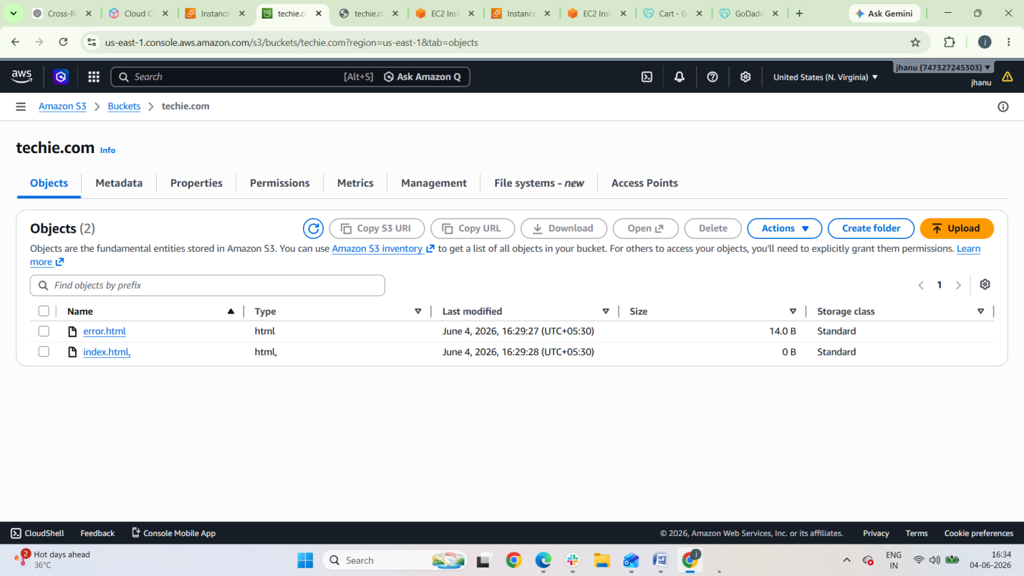

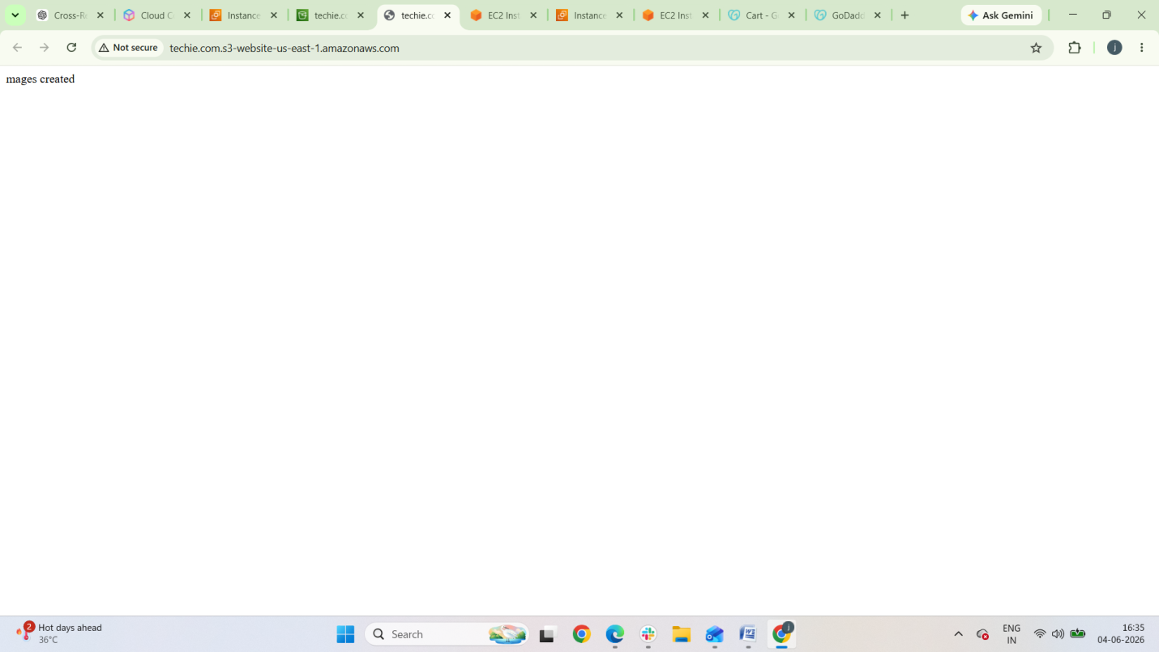

3.Create a CDN and attach one SSL certificate

